FFT September 2023
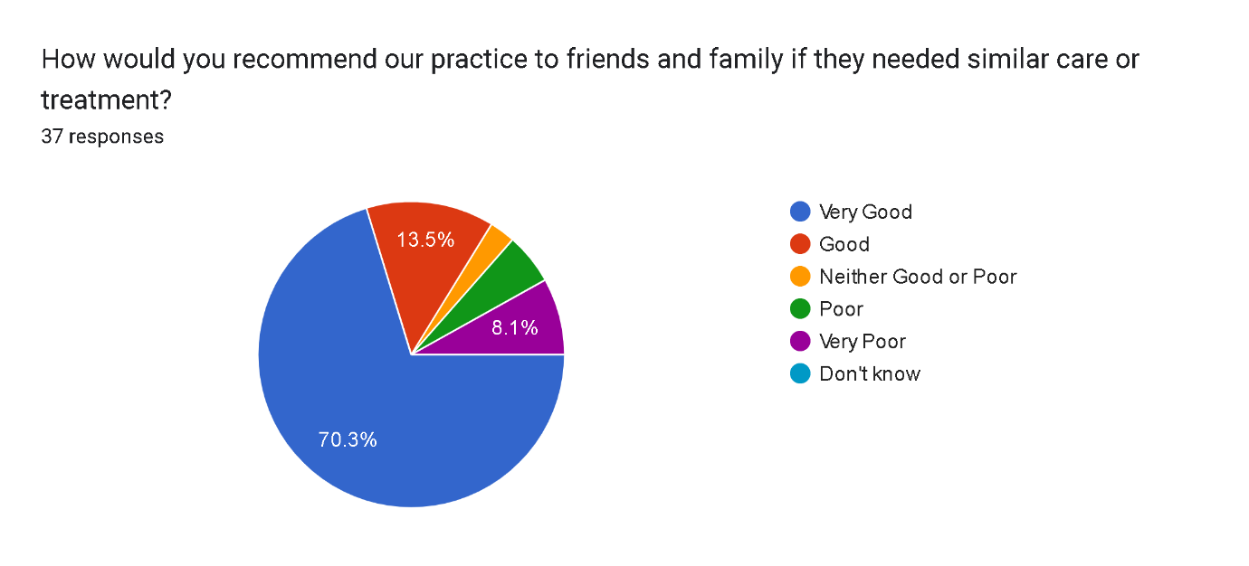

Very good 26 2
Good 5 1
Neither good or poor 3 0
Poor 2 0
Very poor 1 1
Total SMS 37 4 Total written

Very good
Good
So far I have no issue with the surgery
Can't default the service in any way.Dr David is very helpful ,polite and kind in any help you need
Having a Saturday Clinic would be great for working parents.
V.Happy with staff and doctors very caring too
Staff should make patients aware that they will be able to see doctor for one condition at each appointment instead of telling them to speak to the doctor about connecting issues when they see doctor.
Dr David needs bedside manners
Extremely well
Excellent
no need to improve, everything is perfect 👍🏼 staf and doctors are very nice reply and good explaining.
Regular staff who recognises the patients to be available.
Well diagnosed and very well treated.
doctor will only see for 10 minutes and only question from customer please can you improve to 3 shorts questions thanks
Very nice and professional service. THANK YOU 😊
I was seen by the doctor same day so services improved
Very Poor. Had to wait for 45 mts after my appointment time on a working day.
Very good and efficient service
Very helpful
VERY GOOD 👍
Getting appointments is getting bit difficult now.
Very poor service, every time you call line are super busy, but when u actually go to clinic its empty, but they are always fully booked and ask to go to hospital for emergency. Mostly book telephones appointment but then too no one calls you. If i m in pain today they offer you appointment after few days. Cannot understand what sort of clinic they are running. Very Ridiculous service unfortunately in my area where i live i am registered here as its nearest one so has to stick with this clinic. But i had never seen any improvement even after you write bad review. But yes they will still ask to review after appointments
I asked many times for referring to senior specialist doctor (gynaecologist) for my serious health concern but my request gets ignored every time saying NHS is busy, neither kenton clinic look into issue and they don’t give medication even after asking. This is not expected from a GP.
None needed
Always support from drs and receptionist staff
We happy with the service
Staff are helpful
Good service
The staff does not know what is happening they are not helpful if required an appointment
Service is very good
Better arrange a proper vaccination schedule for migrated kids, as they were clue less on two occasions even after I provide them with my kids UpToDate vaccination history to them
I was a little pessimistic about my sons visit to gp but he was well looked after and we left with no tears thanks to Dr David.
Not on time
! was able to be seen on the same day by a GP. Also the phone is always answered, which is great and the receptionist is polite thank you.
The staff and nurses are excellent and very professional and helpful. I can’t thank you enough for it.
Sa far since joining this doctor surgery since 2018 I am very happy.

