FFT October 2023
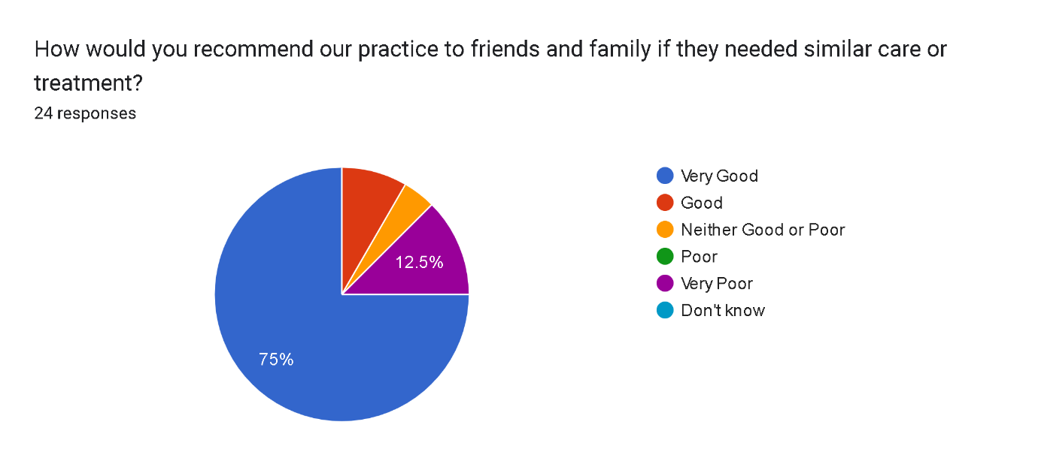

Very good 18 1
Good 3 1
Neither good or poor 2
Poor 1 0
Very poor 0 0
Total SMS 24 2 Total written

Excellent service
M Sunanthirakumaran ma’am was so so understanding she asked me everything discussed everything Im now feeling better than ever
Great service
Your device is v good
Check up was done very smoothly by the doctor & I feel very friendly when I was there for registration. ☺
Just wondering if my blood glucose sugar had been measure or not
It was my first visit to GP in UK and I left the clinic in tears because of that service. Unfortunately, I haven't the opportunity to visit my doctor in Ukraine now, so I had to come for help to your clinic. I have a few health problems, but after the first question the GP said that for another problem I have to book another appointment, because he has only 10 minutes for each patient. He even didn't want to listen to me anymore! But it could be enough time to answer 3-4 questions, not only one in 10 min! My appointment was probably about 2 min! I was thinking doctors have to help people, but it doesn't look that way here... I was already disappointed when I visited the clinic first time and had an appointment in a smelly room where nobody probably ever opens windows for fresh air. And the girl without uniform, without gloves took my blood test. She even didn't wash her hands after using a computer before to take a syringe. I was really shocked! I hoped that at least GP would be better... I hope, that not all doctors are the same. So, I have to look for another GP, who takes care of his patients.
Doctors , lab test assistant and receptionist- everyone seems to be very busy and always in hurry to hung up and I would say they are kind of being very rude to the patient. They do not know how to take blood test. Doctor doesn’t want to listen to what patient has to say or disclose. And moreover coz of the poor listening skills of doctors and receptionist, patient has to wait for next appointment which is likely to be a week or two longer. I must say that NHS should check this clinics doctors. They are not meeting the expectations of the patients and are not being helpful.
Friendly polite
I left a feedback yesterday already. But just now I checked records in the app, where GP wrote, that I said: "I have many other things to discuss". Why does he lie? I didn't say like that! I just said, that I have a few questions, but he even wasn't interested. Even when I said that another problem was more important, but he didn't want to listen. Where may I read this rule, that I can ask only one thing at the appointment? Or how can I book a few appointments at the same time (for example from 9.00 till 9.30, if I have 3 questions)? Or do I have to come there every day or three times per day in different time? How may I know all of these, if it's much different than I got used to in Ukraine? You don't give this information when I book an appointment.
Always excellent service and all staff are very helpful
Very eviecent
No feedback, you guys are doing the best!
Bit slow and long wait for pick the call . Also I have call for 2 days to ask or sick note to write it. (I mean same one thing but need remind)
Brilliant Practice and doctors and nursing staff. Very professional and efficient Admin staff too.
All good
Online booking perhaps
Very good
Great over the phone customer service
Even though doctors are very good, like to have a female doctor for ladies problems.
Service in clinic was excellent
Good service
Excellent service, very friendly staff. No problems with appointment at all, Highly recommend this GP surgery.

