FFT August 2023
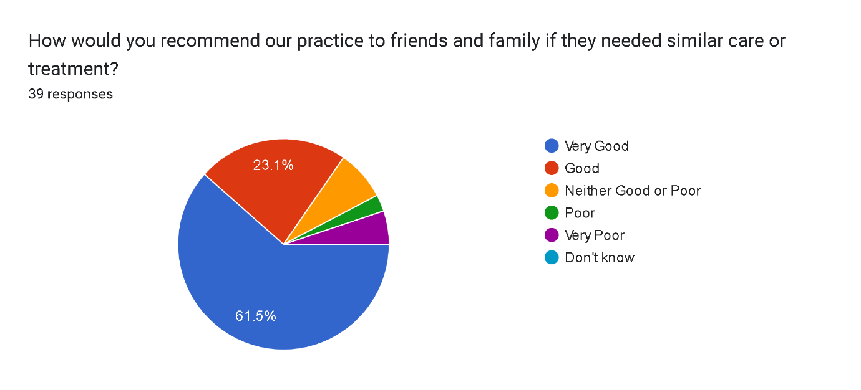

Very good 24 3
Good 9 0
Neither good or poor 3 0
Poor 2 0
Very poor 1 0
Total SMS 39 3 Total written

Very good service, very helpful receptionist, very good doctors too.
Very helpful receptionist, Nurse doctor and staff. Clean and comfortable.
Always good response and all doctors and staff are very helpful..
Very good doctor
All my appointments are punctual.
Time keeping surgery mane you wait over an hour for an appointment
Excellent service but waiting is too long i think you give little more time because after seeing the patient it take time to enter in the computer and after blood test to make sure you do paperwork straight away so no confusion at the end of the session doing all it takes time so this is my opinion thanks xx
Please be kind to older people as some have hearing problems like me
Faster waiting times
Always very friendly. Never have any problems making appointments.
Very good
The service at present in the surgery is very good
Good
Front screen did not work may be once the receptionist starts should check it’s working She checked me in manually but when I left it was still not working and people were asking
it’s excellent no need for any changes.
I came for blood test but unfortunately they couldn’t get the the test done and told me to rebook with adr david
I am very happy with the service provided by the Kenton Clinic.
Very good services
Fairly good too long to wait
None
All staff nice and good service
I had a good experience
It's good and supportive
Very good 😊
I am quiet happy always with the clinic receptionist they are always very very polite. I must say dr Alhtar Ingliee very kind dr listen to me always carefull with out any hurry. I am sorry I have forgotten the name of new young lady dr she is also very polite and helpful.
Looks after patient very well
Excellent service
Not helpful staff. Requested blood test for my allergies and they were reluctant to do so. And referrals taking so long 6-8 weeks
You should check properly before calling a person for a blood test.
I was very impressed with the 2 nurses did my blood test as it’s very difficult to find the right vein but both of them took extra care and done it
nothing to improve its best.
N.a. very good care delivered. quick appointment given. Thank you
The service is absolutely excellent. I don’t believe there is room for improvement.
The service and staff quite good and helpful but in emergency or if kids need appointment in emergency i want
No comments
Keep doing what you are doing.
Very professional al. Well organised snd efficient
Good polite Nurse
Not thorough at all. Doctors sigh and look at you in a very funny way when u explain your symptoms to them. As if you were talking ina foreign language.
Very God service best in London

